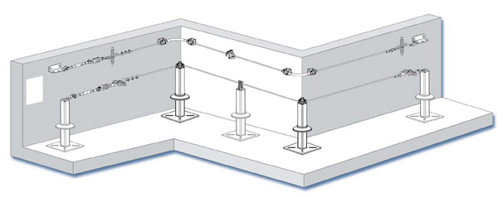

a) Horizontal Lifeline System
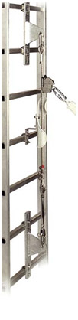

b) Vertical Lifeline System

